

Development and Optimization of An IOT Spider Robot for Home and Industrial Security with Emergency Response

NSBM Green University Town

Faculty of Computing

December 2024

**By**

**BHKL Dayawardana**

**(21871)**

**CONTENTS**

**CHAPTER 1- INTRODUCTION** 4

**1.1Chapter Overview** 4

**1.2 Problem Background** 5

1.2.1 Problem Discussion/Argument 5

**1.3 Problem Statement** 6

1.3.1 Background 6

1.3.2 General Problem 7

1.3.3 Specific Problem 7

**1.4 Research Question** 8

**1.5 Research Motivation** 9

**1.6 Research Aim** 10

**1.7 Research Objectives** 12

1.7.1 Identify 12

1.7.2 analyze 13

1.7.3 To Design / Implement / Develop 13

1.7.4 To Evaluate 15

**1.8 Visualizing the Workflow and System Integration** 16

**1.9 Resource Requirements** 17

1.9.1 Hardware 17

1.9.2 Software 18

**1.10 Project scope** 18

1.10.1 Defining the Project Scope: Inclusions and Exclusions 18

**1.11 Chapter Summary** 19

**CHAPTER 02 - LITERATURE REVIEW** 20

**2.1 Chapter overview** 20

**2.2 Conceptual taxonomy of the literature organization** 20

**2.3 Domain Overview** 21

**2.4 Existing Systems** 22

**2.5 Technological Analysis** 23

2.5.1 Algorithmic Analysis 23

2.5.2 Design analysis 23

2.5.3 Workflow analysis 23

**2.6 Reflection and Research Gaps** 24

**2.7 Chapter Summary** 25

**CHAPTER 03 - METHODOLOGY** 26

**3.1 Research Paradigm: Positivism** 26

**3.2 Research Approach** 27

3.2.1 Inductive 27

3.2.2 Deductive 28

**3.3 Research Strategy** 29

3.3.1 Experimental Approach 30

3.3.2 Action Research 30

3.3.3 Case Study 31

**3.4 Fact collection mechanisms** 32

3.4.1 Questionnaires 33

3.4.2 Interviews 34

3.4.6 Focused Discussion 34

**3.5 Research Execution** 35

3.5.1 Problem Identification 35

3.5.2 Relevance Justification 35

3.5.3 Comparative Analysis and Gap Justification 35

3.5.4 Define and Finalize Objectives 35

3.5.5 Design / Development / Data Management and Handling 35

3.5.6 Evaluation and Communication 36

**3.6 Project Management** 36

3.6.1 Project Management: SCRUM 37

3.6.2 Timeline 38

**3.7 Chapter Summary** 42

**CHAPTER 04 - SYSTEM REQUIREMENT SPECIFICATION** 43

**4.1 Chapter Overview** 43

**4.2 Stakeholder Analysis** 43

4.2.1 Onion Model 44

**4.3 Operationalization Process** 44

4.3.1 Mapping of Questions 44

**4.5 Use Case Diagram** 45

**4.6 Class Diagram** 46

**4.7 Activity Diagram** 47

**4.8 Architecture diagram** 48

**4.11 Functional and Non-functional requirements** 49

**4.12 Chapter Summary.** 49

**CHAPTER 05 - IMPLEMENTATION / DESIGNING** 50

**5.1 Implementation and Design** 50

5.1.1 Steps for Framework Creation and Design 50

5.1.1 flow charts 51

5.1.2 Technology selection 52

**5.2 Key Implementation and User Interface Design** 52

**5.3 Chapter Summary** 55

**CHAPTER 06 - TESTING AND EVALUATION** 55

**6.1 Chapter Overview** 55

**6.2 Test Plan and Test Cases** 55

6.2.1 Non-Functional Testing 55

6.2.2 Functional Testing 56

**6.3 Review on Test Strategies Used** 57

6.4.3 F-measure / Precision / Recall 57

**6.5 Chapter 6 Summary** 57

# **CHAPTER 1- INTRODUCTION**

## **1.1Chapter Overview**

This chapter discusses the spider robot project, particularly built for boosting home security in Sri Lanka utilizing IoT technology. The robot contains six lags, enabling it to walk successfully on different interior surfaces, such as carpets and tiled floors, making it well-suited for Sri Lankan houses. It incorporates modern sensors to detect gas leaks, fires, or intruders, offering an extra protection while homeowners are not there.

When a possible danger is discovered, the robot delivers quick notifications to the owner’s mobile device via a linked application. This guarantees that homeowners are continually informed about the state of their property, allowing them to react swiftly to crises and boosting overall security.

In addition to its main security responsibilities, the robot monitors around variables, including temperature and humidity, as well as its own battery level. Where humidity and temperature variations may influence house safety. Furthermore, the system incorporates a another external unit that may be connected into conventional power outlets. If the robot senses a fire, it sends a signal to this device, which may switch off the power supply to avoid additional damage and safeguard the property.

This chapter will offer an overview of the project, explaining its aims and the technologies employed, including the ESP8266, Arduino, and numerous sensors designed for monitoring the home environment. Additionally, it will explain how the robot connects with mobile and online apps via the BLYNK 2.0 platform, ensuring homeowners stay informed and in charge of their home security.(Filliat et al. 1999; Perilla et al. 2018; Al-Kuwari et al. [no date])

## **1.2 Problem Background**

A growing number of house invasions, burglaries, and mishaps like fires and gas leaks have made home security a top priority in recent years. Although they sometimes have drawbacks, traditional security systems, such cameras or alarms, may inform homeowners. For instance, they may not cover the whole home, or they might not function well under certain circumstances, such as a power loss.

Moreover, a lot of security systems don't do anything until after an incident occurs, like a fire or break-in. This implies that the homeowner often receives notification too late to avert harm or risk. A more sophisticated system that can monitor, identify, and react to different hazards within the house even while the homeowner is away required due to this weakness in proactive home security. (Baballe [no date])

### **1.2.1 Problem Discussion/Argument**

The concept of using robots with IoT (Internet of Things) capabilities emerged from the demand for more intelligent home security systems. A mobile robot, as opposed to a typical system, can travel across various surfaces, such as carpets or stairs, cover blind spots, and look after for different areas of the home.

This IoT idea presents the concept of a six-legged spider robot that can check for dangerous conditions like gas leaks or fires and detect intruders and also the robot provides an mobile and web application protection by using sensors such as fire sensors, gas sensors, and PIR motion detectors and few other senser to check robot status.

Furthermore, it is unusual for current systems to be able to control the electrical safety of the home. One innovative component of this spider robot concept is its ability to interact with an application that is powered by the home's electricity source. If a fire is detected, a safety feature that cuts off the power to the whole home to stop more damage.

Therefore, the topic of debate is on how the inability of present home security systems to actively react to threats in real time. The spider robot's mobility, intelligent sensors, and capacity for proactive response when required fill these gaps. (Baballe et al. 2021)

## **1.3 Problem Statement**

For the purpose of this section, the precise issues that the project intends to address are defined. The limits of the home security systems that are now available are discussed, and the need of a more modern solution that is able to monitor, identify, and react to dangers that are present inside the home is brought to light. By providing an overview of these difficulties, the issue statement lays the groundwork for the reasons why this spider robot project is essential and the ways in which it may fill the holes that was previously present in conventional security systems.

### **1.3.1 Background**

More people are adopting security systems as their concerns about the safety of their houses grow. Traditional security technologies, such as closed-circuit video cameras, motion detectors, and sirens, have various disadvantages. Many of these devices are permanently fixed, therefore they cannot fully cover the whole home. They also rely heavily on an internet connection or a power supply, which may make them vulnerable during outages or system malfunctions.

Recent improvements in IoT technology have offered smarter solutions, where devices can communicate with one other and deliver real-time warnings to homes via mobile apps. Despite these developments, many home security systems still do not provide proactive functions, such the capacity to roam about the house or react to particular risks like fire or gas leaks. Additionally, most systems only inform the homeowner after an incident has happened, giving little time to respond before harm is done.

This concept solves these difficulties by integrating IoT technology with a mobile robot that can actively patrol the home and identify dangers in real time. With capabilities such as gas leak detection, fire alarms, and intruder monitoring, this spider robot delivers a more complete and dynamic security system for contemporary houses.

### **1.3.2 General Problem**

The primary issue with conventional home security systems is their restricted capacity to stop or lessen harm caused by dangers such as gas leaks, fires, and incursions. Usually, these systems don't identify issues until they arise, which leaves the homeowner with little time to take preventative measures to avoid harm or risk. For instance, a fixed camera could record video of a break-in, but it can't stop the burglar or notify the owner beforehand.  
  
Furthermore, conventional systems are unable to react to various threats. While some are capable of detecting motion, they often miss additional threats like gas leaks, temperature increases, or fire breakouts. Due to this, houses are more susceptible to various situations, which, if they are not promptly handled, may result in expensive damage, loss of property, or even fatalities.  
  
In essence, homes who don't have an integrated, live security system are left without complete protection. This issue highlights the need for a more sophisticated system that can keep the house secure by acting pro-actively and detecting different threats.

### **1.3.3 Specific Problem**

The majority of home security systems are built to target certain risks, including motion detection or surveillance. Unfortunately, since these systems are often installed in one location, it may be difficult to cover every section of the house, particularly the blind spots. For instance, cameras are unable to travel about the home or patrol it, thus certain sections remain unmonitored.  
  
The incomplete integration of conventional home security systems with additional safety measures is another major problem. While some systems are capable of detecting intruders, very few have the ability to monitor environmental parameters like temperature and humidity or detect fires or gas leaks. This results in a gap in security coverage as it may be expensive and difficult to maintain for homeowners to install numerous systems in order to handle various threats.  
  
Furthermore, the majority of current systems are incapable of taking proactive measures to halt harm before it becomes worse. For example, in the event of a fire, conventional systems are limited to informing the homeowner; they are unable to initiate an action to turn off the power to stop the spread of the fire.  
  
By developing a mobile, all-in-one spider robot that can patrol the home, identify various threats, and even initiate safety measures like turning off the electricity in the event of a fire, this project specifically solves these drawbacks. The area of unmet need in the field of home security research is the creation of a complete, integrated system that incorporates mobility, many sensors, and proactive measures—all of which are currently uncommon in current systems.

## **1.4 Research Question**

The question this project seeks to answer is:

**"** **How to make a mobile robot with sensor-equipped, increase home security by detecting and reacting to multiple threats such as invasions, gas leaks, and fires, while giving real-time notifications to the homeowner?"**

This research topic focuses on providing a complete home security solution that overcomes the limitations of previous systems. It intends to examine how a six-legged spider robot, coupled with numerous sensors and IoT capabilities, can actively monitor the house and identify possible risks and react to them.(Taryudi et al. 2018; Gul et al. 2019)

The question key areas:

Mobility

* Can a mobile robot offer superior security coverage compared to fixed equipment by roaming the home and reaching regions where static cameras or sensors cannot?

Threat Detection

* How well can the robot employ several sensors (such gas, IR, and PIR motion sensors) to identify different forms of hazards in real time? This includes incursions, fires, gas leaks, and environmental conditions like as temperature and humidity.

Preventive Action

* Can the robot not only identify risks but also take preventive steps, such as sending signals to turn off the home’s power supply during a fire to limit additional damage.

Real-Time Alerts

* How effectively can the robot transmit alerts and notifications to the homeowner's mobile device via the BLYNK 2.0 platform, ensuring the owner is aware and can take action, even while away from home?

Robot Self-defense system

* How to defend the robot from burglars?
* How to defend the robot if someone is try to touch it or destroyed while it’s on security mode?

Although this study focuses on developing a full security system, there are sub-optimal zones to consider. For example:

* The robot’s capacity to identify hazards can be restricted by sensor range or environmental interference.
* There can be issues in ensuring the robot operates smoothly across diverse surfaces or confined areas.
* Battery life might restrict how long the robot can patrol before having to recharge.

## **1.5 Research Motivation**

The fundamental purpose of this project is to build a unique spider robot meant to increase home security in Sri Lanka using superior mobility and sensor technologies. This initiative attempts to solve particular security concerns encountered by households in the nation, such as burglary, fire dangers, and gas leaks. By the conclusion of this project, we intend to accomplish three critical results that will substantially enhance home safety and give peace of mind for homeowners.

* Individual Experiences

The worry and terror associated with home security problems, like break-ins, fires, or gas leaks, are well-known to the public. Families are distressed emotionally as well as physically by these occurrences, which endanger their safety. For me, seeing a friend's house broken into deeply worried about home security. This incident made clear how exposed houses can be, particularly when conventional security systems fall short of meeting security requirements.

* Growing Concerns About Safety

Statistics show an increase in fire incidents and home invasions. This alarming trend emphasises the critical need for efficient home security systems. Furthermore, a common omission is the risk of gas leaks, which can cause fires or explosions. The National Fire Protection Association reports that fires that are discovered after the fact account for nearly half of home fire fatalities. This data lends credence to the idea that homeowners need a proactive security system that can spot threats before they become dangerous situations.

* The Need for Innovation

This study was also driven by the urge to develop and enhance current security solutions. Many of the solutions available today are constrained by their fixed nature; they only use cameras or alarms, which can only respond after an event has occurred. This gap offers an intriguing chance to create a mobile security system that keeps an eye out for potential threats like gas leaks and fires in addition to detecting breaches. The development of a robot capable of preemptive maintenance, like turning off the electricity in the event of a fire, is a major step forward for home security.

* Advancements in Technology

Home security systems have become more sophisticated and adaptive as a consequence of real-time data collecting and device connection made possible by the Internet of Things (IoT). There is a unique opportunity to create a mobile robot that can monitor the home environment proactively thanks to recent advancements in robotics, sensing, and communication technologies. The potential of combining these technologies led to the idea of developing a spider robot that can patrol the home, recognise various threats, and communicate with homeowners instantly.

* Conclusion

Personal experiences, a rising concern for home safety, the urgent need for improved security solutions, and the exciting potential of new technologies are the sources of inspiration for this study. In all, the motivation for this research derives from a combination of these factors. By addressing these reasons, the objective is to build a home security system that is both comprehensive and effective, with the purpose of providing homeowners with peace of mind and guaranteeing that they possess a sense of safety and security inside their houses.

## **1.6 Research Aim**

The fundamental purpose of this project is to design a unique spider robot that promotes home security in Sri Lanka via mobility and superior sensor technologies. By the conclusion of this project, we intend to accomplish six critical results that will help to enhancing home safety for homeowners throughout the country.(Carroll et al. [no date])

* Development of a Mobile Security Robot

The principal purpose is to develop and construct a functioning prototype of the spider robot. This robot will have six legs, enabling it to travel smoothly over diverse surfaces in homes, such as carpets, tiled floors, and uneven terrains often seen in country residences. By making the robot mobile, it can patrol various sections of the house, addressing blind spots that fixed security cameras or sensors typically overlook. This element is significant since many break-ins occur in less visible regions, and a mobile solution may give greater overall coverage.

* Integration of Multiple Sensors

Another key purpose is to incorporate numerous sensors into the robot, including PIR motion sensors for detecting intruders, gas sensors for diagnosing leaks, and IR sensors for detecting heat from fires. Where natural catastrophes like fires may pose a severe threat, having a multi-sensory approach would guarantee that householders are alerted to threats in real-time, giving them a greater opportunity to react effectively before a problem worsens.

* Real-Time Communication with Homeowners

We want to develop a strong communication system between the spider robot and homes utilising the BLYNK 2.0 platform. This platform will allow the robot to deliver real-time alarms and notifications to the homeowner’s mobile device. Whether it’s an intruder identified by the motion sensor, a gas leak, or a fire threat, the homeowner will get timely notifications. This timely information is crucial for taking rapid action, such as calling local authorities or evacuating the premises.

* Implementation of Preventive Safety Features

A significant objective from this study is to create preventative safety measures that may limit harm during crises. For instance, if the robot senses a fire, it should be able to send a signal to a linked device that may switch off the home’s energy, lowering the danger of future risks. In Sri Lanka, where electrical safety is a serious issue, this preventive strategy may assist prevent fires from worsening and safeguard both lives and property.

* User-Friendly Design and Usability

We also want to design a user-friendly interface for both the mobile and online apps, enabling homeowners to effortlessly monitor their home security. The application should give basic controls and clear information about the robot’s condition, battery level, and any alarms. Ensuring that the system is straightforward to operate will encourage more homeowners to use this new technology, making their homes safer.

* Contribution to Research and Technology

Finally, this project hopes to contribute to the larger area of home automation and security technologies in Sri Lanka. By researching the combination of robots, IoT, and sensor technologies, this project may give useful insights and new routes for future developments. The results might stimulate continued development of such technology, ensuring a safer environment for households throughout the nation.

## **1.7 Research Objectives**

The CREATE of a spider robot especially intended to improve home security in Sri Lanka is the main goal of this project's research aims. Homeowners are looking for creative ways to safeguard their assets and security worries rise. With the use of cutting-edge sensor technology and mobility, this project seeks to develop a robotic system that would meet these urgent demands.  
  
Each aim mentioned in this part emphasizes a distinct component of the research process, directing the overall design, execution, and assessment of the robot. These goals serve as a roadmap, ensuring that all relevant components are properly studied and developed to produce a complete security solution. By concentrating on these goals, we hope to guarantee that the robot is effective, dependable, and user-friendly, satisfying the particular security needs of homes.

### **1.7.1 Identify**

To identify the key security dangers faced by households, such as burglary, fire hazards, and gas leaks. This purpose attempts to learn the unique hazards and problems residents encounter, which will impact the design and functioning of the spider robot.

In Sri Lanka, home security is a growing issue due to several causes, including expanding urbanization and the possibility for both human-related and natural dangers. Burglary is one of the most prevalent security hazards, particularly in metropolitan locations where residences are left unattended for lengthy periods. Fires, typically caused by poor wiring or neglect, offer another severe concern, while gas leaks from kitchen equipment or pipes may result in fatal repercussions if not identified early.

To reach this purpose, we will undertake research via surveys, interviews, and case studies with homeowners, security professionals, and municipal officials. These strategies will help us acquire firsthand data on the most prevalent and serious hazards in households. We will also review local criminal reports and fire department information to better understand how frequently these occurrences occur and in which places they are most common.

By understanding these security issues in depth, we may adapt the spider robot's characteristics to meet particular concerns. For example, if gas leaks are shown to be a prevalent concern, the robot would prioritize the integration of gas sensors to offer early alerts. Similarly, in locations prone to break-ins, the robot’s motion detection and surveillance functions will be tailored for increased efficacy.

Ultimately, identifying these dangers will enable us to create a solution that offers optimal protection for Sri Lankan houses, making the spider robot a highly personalised and efficient security system.

### **1.7.2 analyze**

To assess the present home security systems and technologies currently accessible in Sri Lanka. This aim focuses on investigating the many home security gadgets that are routinely utilised by homeowners to secure their houses. By evaluating these systems in depth, strive to understand their strengths, weaknesses, and areas that want development. This study will guide the design of the spider robot to ensure that it meets gaps in existing solutions.  
  
many households depend on conventional security systems such as alarms, CCTV cameras, and simple sensor systems. While these technologies offer a measure of safety, they typically have limitations that make them less successful in totally defending residences. For instance, simple alarm systems may occasionally be activated mistakenly or fail to react to more sophisticated break-in tactics. Similarly, CCTV cameras provide passive monitoring, but they demand continual attention and do not deliver real-time warnings until connected with other technologies. Environmental sensors, such as smoke or gas detectors, are generally solitary devices that don’t connect with other systems, restricting their capacity to offer a full safety solution.  
  
This aim entails a complete analysis of various security systems via market research, product comparisons, and customer feedback. We will assess how each sort of security equipment works in various scenarios—such as detecting intruders, reacting to fire dangers, and finding gas leaks. Additionally, we will look at how these systems are priced, how accessible they are to the general people, and how simple they are to install and utilise in homes.  
  
By extensively evaluating these current systems, we can determine the fundamental shortcomings that our spider robot may improve upon. For example, if we discover that many systems lack real-time warnings or are not mobile enough to cover blind areas in houses, the spider robot will be created with mobility and immediate alerting capabilities. Similarly, if existing solutions are costly or difficult to maintain, we will work on making the robot economical and user-friendly.

### **1.7.3 To Design / Implement / Develop**

To design, implement, and build a prototype of the spider robot equipped with sophisticated sensors and mobility abilities. This purpose is concentrated upon the actual building of a working spider robot that can successfully increase home security by travelling diverse surfaces and identifying possible dangers. The robot’s design and development will combine sophisticated sensor technologies, mobility systems, and user-friendly communication features.  
  
A significant aspect of the design is the robot’s mobility. Since houses contain a range of surfaces, including carpets, tiles, and hardwood floors, the spider robot must be able to travel smoothly and consistently over these diverse kinds of flooring. The six-legged design of the robot gives stability and flexibility, enabling it to travel across the home without being hampered by impediments like carpets or uneven floors. This adaptability will guarantee the robot can watch every aspect of the property, boosting security coverage.  
  
For the body of the robot, I will utilise clear plastic glass sheets. This material is lightweight but sturdy, offering protection for the internal components while giving the robot a sleek, contemporary look. The transparency of the plastic glass sheets also permits easy sight of the interior mechanics, which might be advantageous for troubleshooting or maintenance.

* The robot will have this set of sensors to read environment
* Gas sensors will be used to identify dangerous gases, such as propane or natural gas leaks, which may represent a major threat if not recognized early.
* Fire detection sensors (presumably infrared or temperature sensors) will be included to monitor for rapid spikes in temperature or flames, enabling the robot to immediately inform homeowners in the case of a fire.
* PIR motion sensors will detect movement within the house, helping to identify possible burglars while the homeowner is not there.
* The temperature sensor will detect excessive heat levels, helping you spot early indicators of fire or overheated equipment before they become a significant concern.
* The humidity sensor will monitor moisture levels, which may be spotting possible problems like leaks, or excessive wetness.
* Sensors for mobility and functionality of the robot.
* First ultrasonic sensor: this sensor will identify objects in front of the robot, such as walls or furniture. When the robot detects an obstruction in its route, it will raise an alarm and measure the reflection. The robot can navigate the home with ease since it can sense obstacles and change course to prevent mishaps.
* Second Ultrasonic Sensor: This sensor will be placed to identify any dangers such as stairs, hills, or other uneven terrain that the robot may not be able to navigate. With the aid of this function, the robot will be able to securely explore the house without running the danger of hurting itself or its surroundings by falling or becoming trapped.
* The robot's power supply will be continually monitored by an inbuilt battery level sensor. When the battery is getting low, this sensor will determine its charge level and alert the homeowner using a mobile application. This guarantees that there won't be any unplanned power outages, enabling the robot to go on efficiently monitoring the house.

Beyond danger detection, the spider robot will also be built to interface with a smartphone application utilizing the BLYNK 2.0 platform. This will enable the robot to transmit real-time notifications to the homeowner’s smartphone anytime a hazard is identified, whether it’s a gas leak, fire, or break-in attempt. The robot will also monitor environmental parameters like temperature and humidity, giving residents with frequent information regarding their home’s safety condition.

### **1.7.4 To Evaluate**

To assess the performance and efficacy of the spider robot in real-world circumstances. This aim focuses on testing the spider robot to verify that it accomplishes the desired objectives of boosting home security and providing dependable monitoring. The study will analyse how effectively the robot works in identifying different dangers such as invasions, gas leaks, fires, and environmental changes and how efficiently it conveys these concerns to the homeowner.

The assessment will be undertaken via real-world testing in diverse household contexts, such as apartments, houses with several rooms, and homes with varied flooring kinds (e.g: carpet, tile, and hardwood). By deploying the robot in various varied environments, we will be able to test its adaptability, precision, and overall dependability. Specific areas of concentration will include:

* Navigation

Evaluating the robot's mobility over diverse surfaces and its ability to avoid obstacles and dangers like walls, furniture, stairs, or slopes, using its ultrasonic sensors. This will guarantee the robot can securely and effectively travel around diverse house layouts.

* Communication

Measuring the usefulness of the robot’s contact with the homeowner through the mobile app, including the speed and reliability of real-time alerts when a threat is identified.

* Threat Detection: Assessing the robot's proper identify possible hazards including gas leaks, fire, and intruders using its integrated sensors. I will assess how soon and efficiently the robot recognizes these hazards.
* Battery Life: how long the robot can work on a single charge

Ultimately, this assessment will offer a clear image of how effectively the spider robot operates in real-world conditions.

## **1.8 Visualizing the Workflow and System Integration**

This chapter shows a graphic depiction of the suggested spider robot system for home security. I will use this design to define the system main components and how they work with each other.

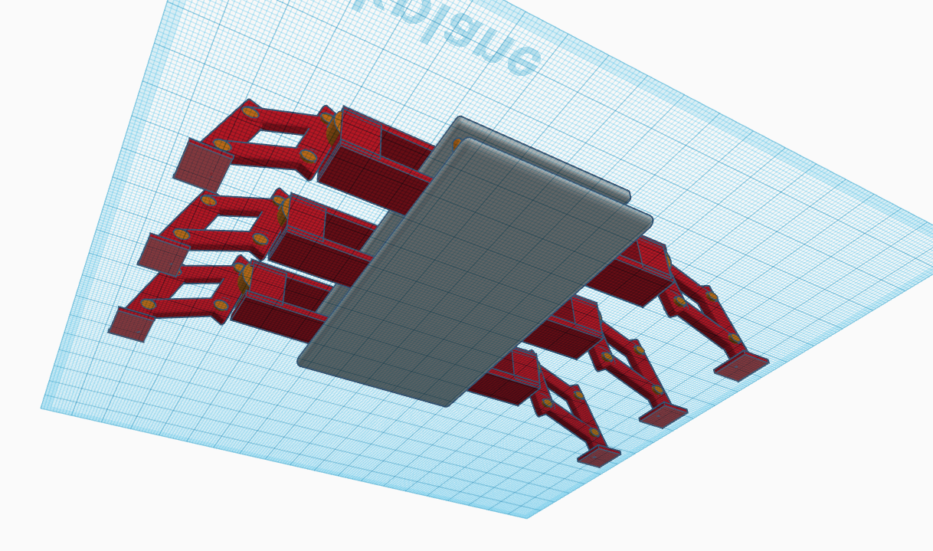

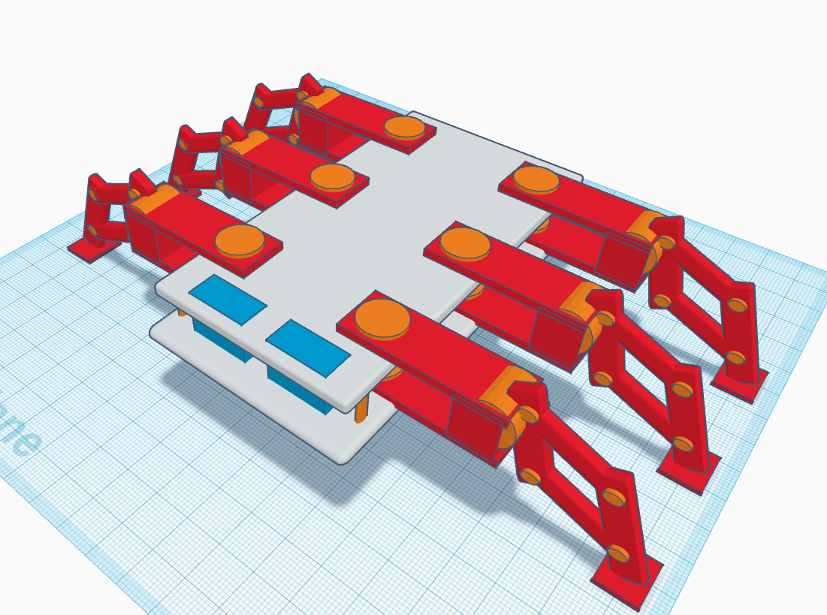

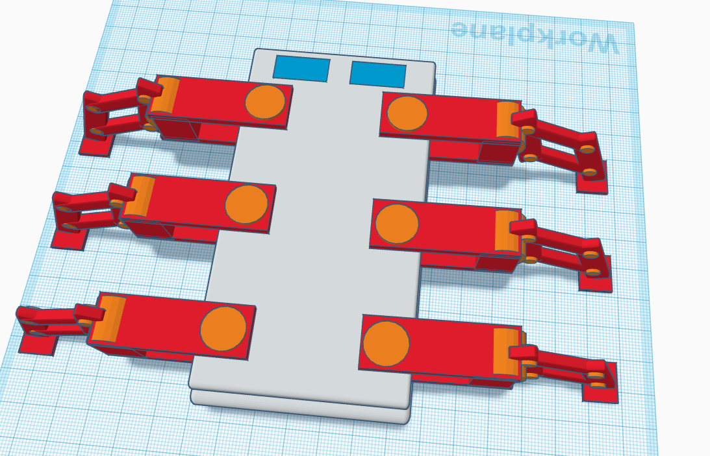

**1.9 Resource Requirements**The essential materials required for the effective conception, creation, and deployment of the spider robot system for home protection are listed in this section. Hardware and software needs are separated into two groups.

### **1.9.1 Hardware**

1. ESP8266 (Wi-Fi Microcontroller) – for communication with the mobile application via the BLYNK platform.
2. Arduino Board – Used to control lags of the robot.
3. 12 Servo Motors – To provide mobility and movement to the spider robot’s six legs.
4. Ultrasonic Sensors (x2) – One sensor for detecting objects in front of the robot and another for detecting stairs or slopes.
5. Gas Sensor – To detect any harmful gas leaks like LP gas in the home environment.
6. Infrared (IR) Fire Sensor – For detecting flames or heat.
7. PIR Motion Sensor – For detecting movement inside the house.
8. Temperature and Humidity Sensors – To monitor environmental conditions.
9. Battery Level Sensor – To continuously monitor the robot’s power levels.
10. Transparent Plastic Glass Sheets – Used for constructing the body of the robot.
11. Rechargeable Battery Pack – To power the robot and its sensors.
12. Charger – To recharge the battery pack of the robot.

### **1.9.2 Software**

1. Arduino IDE – For writing and uploading the code to control the sensors.
2. BLYNK 2.0 – A platform for developing the mobile application and web application.
3. C++ Programming Language – Used to program the microcontrollers.
4. Sensor Libraries – Libraries for each sensor type.
5. Cloud Storage (BLYNK/other) – To store data collected from the robot.

## **1.10 Project scope**

### **1.10.1 Defining the Project Scope: Inclusions and Exclusions**

|  |  |
| --- | --- |
| In Scope | Out of Scope |
| Designing and creating a practical spider robot with 6 legs, capable of traversing varied surfaces. | creation of a finished product that is prepared for mass manufacturing. |
| Identifying potential threats to home security by integrating sensors (such as motion, temperature, humidity, gas, and fire). | sophisticated threat response techniques, such as engaging intruders head-on. |
| using BLYNK 2.0 to notify the homeowner in real time about environmental and security concerns. | creating a unique app from the ground up without using BLYNK. |
| avoiding obstructions and spotting slopes or stairs with the use of ultrasonic sensors. | robot charging options that use on solar electricity or wireless technology. |
| Battery level monitoring is included to provide an alarm when the robot needs to be recharged. | Complete firefighting or suppression system. |
| keeping an eye on the house's interior temperature, humidity, and air quality. | External environmental monitoring outside the house. |

## **1.11 Chapter Summary**

In this chapter, I investigated the core parts of the spider robot project developed for boosting home security in Sri Lanka. I started with an introduction of the project, detailing its aims and novel features that employ IoT technology to enable complete monitoring and danger detection. The conversation addressed the distinct security concerns encountered by homeowners in Sri Lanka, underlining the significance of designing a solution that answers these unique demands.   
  
I defined the essential hardware and software resources needed for the project, defining the components that would allow the robot to function efficiently in diverse conditions. The project scope was established explicitly, differentiating between what would be included and excluded in the development process, guaranteeing a focused approach.

Additionally, I defined research goals that drive the design, deployment, and assessment of the spider robot, reaffirming my dedication to providing a dependable and user-friendly security solution. Finally, the chapter addressed the notion of visualizing the workflow via a rich image, which would serve as a guide for understanding the interactions inside the system.   
  
Overall, this chapter establishes the framework for the upcoming parts, preparing the way for a full analysis of the technical requirements, development procedures, and testing stages of the spider robot project.(Cavas 2019; Jdeed et al. [no date])

# **CHAPTER 02 - LITERATURE REVIEW**

## **2.1 Chapter overview**

This chapter provides a thorough literature analysis on the topic of building a spider robot for domestic security, with a focus on the Sri Lankan setting. First, it lays forth the project's theoretical underpinnings and essential principles in an organized fashion. Here we take a look at the home security system landscape as it is right now, showcasing the many frameworks and technologies that are already in use. To determine the relative merits of the proposed solution and the current state of the art, a comprehensive analysis of related systems and designs is provided.

Part of this chapter is an investigation of the technology that will be used to build the spider robot; specifically, it looks at the algorithms, designs, and workflows that will be used. In order to justify any judgements taken, this study will determine if these technologies are appropriate for the situation at hand. At the end of the chapter, there is a reflection that lays out the project's goals and identifies research gaps in the current literature.(Taryudi et al. 2018; Cavas 2019; Gul et al. 2019; Baballe et al. 2021; Baballe [no date]; Carroll et al. [no date]; Surabaya et al. [no date][a])

## **2.2 Conceptual taxonomy of the literature organization**

This part will give the reader an organized overview of the literature studied for this chapter, making it easier for them to understand how the chapter is structured and what its main points of emphasis are.

## **2.3 Domain Overview**

This section provides a cursory but essential overview of the home security industry, emphasizing the significance of security systems overall, typical dangers, and current trends. This foundation helps put the spider robot project in the larger context of home security, which is what this section aims to do.

* Current Trends in Home Security

Rapid technical breakthroughs are occurring globally in the home security market, particularly with the rise of IoT (Internet of Things) devices. Real-time monitoring, remote access, and automation are made possible by these technologies, which improve home security and management effectiveness. Typical patterns involve the application of

* Smart cameras
* Motion detectors
* Voice-activated assistants
* CCTV

Even if the use of these technologies is growing gradually, many homes still rely on outdated security systems and basic locks. On the other hand, as new technology and IoT awareness increase, so does the need for more sophisticated security solutions.

* Common Threats in Home Security

A number of threats highlight the need for improved home security systems. a few of the most frequent risks that homeowners must deal with.

* Burglaries and break-ins.
* Fire hazards.
* Gas leaks.
* Environmental threats.
* Significance of Security Systems

The suggested spider robot is an adaptable and economical solution that can monitor environmental dangers like gas leaks and fires in addition to detecting intrusions. Many existing systems aren't mobile enough or have the multi-sensory capabilities that a robot could, so this kind of innovation gives homeowners a chance to control security concerns in a way that works for them and their property.

In order to assess how the spider robot could address current shortcomings and offer a more versatile, portable, and technologically sophisticated answer to typical home security issues, this section first establishes this knowledge of the home security domain.(Kodali and Gorantla 2018; Perilla et al. 2018; Taryudi et al. 2018; Baballe et al. 2021; Al-Kuwari et al. [no date]; Baballe [no date]; Surabaya et al. [no date][b])

## **2.4 Existing Systems**

Here I take a look at the state of home security systems, frameworks, and robot designs as they pertain to identifying and avoiding dangers. I will describe the proposed spider robot's performance in comparison to other systems, such as cameras, alarms, and sensor-based solutions.

* Alarm Systems

Conventional alarm systems, which are commonly utilized, use door/window sensors and motion detectors to sound an alarm when an entry is detected. But they have restrictions.

* Only monitor specific areas.
* don't provide updates unless integrated with smart tech like ESP8266.
* Can be triggered by small movements

The benefit of a spider robot is that, in contrast to static alarms, it can move around the house and identify hazards in various locations. In addition, it keeps an eye out for temperature, gas leaks, and fires, offering a more complete security solution.

* Security Cameras

In addition to collecting video and providing real-time monitoring, cameras can also send out alerts when they detect motion. Although helpful, they have disadvantages.

* Cameras only capture dedicated areas, and it’s fixed.
* don’t do anything beyond recording.

This robot don’t have Cameras but in the other hand the spider robot is its mobility, which allows it to cover a variety of regions that are inaccessible to cameras. In addition to detecting motion, it keeps an eye out for environmental dangers and notifies homeowners in real time.

* Robotic Security Systems

Existing security robots, often outfitted with cameras and sensors, provide autonomous navigation but have limits.

* These robots are high cost
* Some robots struggle with uneven surfaces

The spider robot's six-legged design lets it to walk on a variety of surfaces, including carpets offering it greater mobility than wheeled robots. It's also inexpensive yet providing advanced protection.

## **2.5 Technological Analysis**

This section delves into the technological aspects of home security systems, focusing on how effectively they perform in real-time contexts, structural designs, and workflows. It is separated into three major categories: algorithmic analysis, design analysis, and workflow analysis.

### **2.5.1 Algorithmic Analysis**

In this section, I assess the algorithms employed by existing security robots and sensors, focusing on those that detect motion, temperature, gas leaks, and fire. The emphasis is on how efficiently and accurately these algorithms detect dangers in real time.

The spider robot has an advantage in that it uses modern algorithms to reduce false alarms and enhance danger detection accuracy by merging inputs from numerous sensors (ultrasonic, PIR,Fire, and gas).

An other benefit of using multi-sensor integration to monitor both gas and fire risks, resulting in a greater range of detection and higher accuracy, even in homes with diverse layouts.

Also algorithms in gas and fire sensors frequently detect only particular circumstances.

### **2.5.2 Design analysis**

This section examines the construction of security robots, particularly with regard to their mobility and capacity to traverse various household environments. Given the combination of carpeted flooring, tiles, and potential obstructions like furniture or stairs, a robot's functionality in a typical home is directly impacted by its design.

* A lot of current robots feature treads or wheels that perform well on level ground but poorly on uneven ground.
* The advantage of the spider robot is that it can walk on a variety of surfaces, including carpets, and even avoid obstructions because of its six legs, which are equipped with ultrasonic sensors that can detect objects or drops in its route.
* Transparent plastic glass sheets, which are strong and lightweight and perfect for indoor use, will be used to construct the robot's body. This material is appropriate for general use in both home and industrial settings because it is also reasonably priced.

### **2.5.3 Workflow analysis**

I go over how data moves via different systems in this section, as well as how they manage alert and communication systems. Timely responses to security concerns depend on effective communication.

* When dangers are identified, traditional systems notify users by email or SMS.
* The benefit of the spider robot is that it uses the BLYNK 2.0 platform to communicate in real-time, alerting the homeowner's mobile app when a threat is detected. Beyond merely warning the homeowner, it also works with a wifi relay device that can turn off the house's electricity in the case of a fire.
* Current systems frequently don't provide real-time battery level data, which makes them susceptible to malfunctioning at crucial times.
* The benefit of the spider robot is that it keeps track of its battery level and notifies the homeowner when it needs to be charged, guaranteeing that the system is always functional.

## **2.6 Reflection and Research Gaps**

The literature review is summarized in this section with an emphasis on finding weaknesses in the current home security systems and technologies. A number of drawbacks have emerged from the analysis of existing solutions, indicating the necessity for additional study.

* Reflection on Existing Systems

Alarms, cameras, and static sensors are examples of modern home security systems that excel at issuing alerts and keeping an eye on particular regions. However, their immobile nature, restricted coverage, and lack of motion result in blind spots and lessen their overall efficacy in offering complete protection. Additionally, these systems do not integrate many sensors, which limits their ability to identify a variety of dangers such as gas leaks, fires, or invasions in various parts of a house.

Robotic security systems, while advanced, often face challenges such as high cost, limited mobility on varied surfaces, and difficulty detecting obstacles or stairs. These robots, though innovative, are not fully optimized for the typical indoor environments in Sri Lanka, where uneven terrain, carpets, and obstacles like stairs are common.

* Identified Research Gaps

Existing robotic systems have trouble navigating terrain, and the majority of systems are static. A flexible mobile solution that can go freely on stairs, tiles, and carpets is required.  
  
Current systems frequently concentrate on detecting only one or two hazards, such as fire or motion. There is a lack of a multi-sensor solution that combines environmental monitoring (temperature and humidity), motion detection, gas detection, and fire detection.

Although certain systems issue warnings, they hardly ever take prompt preventative measures. Systems that can actively intervene, like turning off the electricity in the event of a fire, are lacking, which would provide an additional degree of security.

The typical Sri Lankan householder cannot afford the high-tech robotic solutions that are now available. A solution that is both affordable and offers cutting-edge security features is required.

## **2.7 Chapter Summary**

In this chapter, I examined current research and technological advancements pertaining to home security systems, emphasizing both their advantages and disadvantages. Current home security trends were highlighted in the domain review, especially in Sri Lanka, where gas leaks, fire dangers, and burglaries are key concerns.

The algorithms, designs, and processes of these systems were examined in greater detail by the technological analysis. I discovered that whereas current algorithms are capable of identifying particular hazards, they frequently fail to integrate several sensors for thorough coverage. Additionally, the present robots' designs are not flexible enough for Sri Lanka's typical indoor conditions. Furthermore, active threat response such as immediately turning off the electricity in the house.

The reflection concluded by highlighting important research needs, including the requirement for a transportable, multi-sensor, and reasonably priced solution. These deficiencies call for more study to create the suggested spider robot, which will solve these issues and offer a creative, reasonably priced home security solution designed for Sri Lankan homes.

# **CHAPTER 03 - METHODOLOGY**

## **3.1 Research Paradigm: Positivism**

The research paradigm used in this project is positivism, which emphasizes gathering quantifiable and objective data in order to evaluate the spider robot's performance and efficacy in home protection. According to positivism, knowledge is derived from quantifiable and observable facts, and conclusions are free from subjective interpretations or personal judgements.  
  
By going with positivism, I want to evaluate the spider robot quantitatively using things like sensor data, system performance metrics, and quantifiable user input. The project's emphasis on technical analysis and real-world data collection, as opposed to depending solely on subjective interpretations or opinions, led to the choice to adopt this paradigm.



## **3.2 Research Approach**

In order to investigate and verify the spider robot's efficacy for home security, I am using deductive and inductive methods in this research.

### **3.2.1 Inductive**

The spider robot is placed in various home locations and particular information is gathered about how it walks on various surfaces, how well it finds gas leaks, fires, or intrusions, and how well it notifies the homeowner of dangers.

Performance on each different surfaces

|  |  |  |  |  |
| --- | --- | --- | --- | --- |
| Surface Type | Speed Time(s) | Gas Leak Detection Time (s) | Fire Detection Accuracy (%) | Intrusion Detection Accuracy (%) |
| Carpet | 30s | 55s | 80 | 80 |
| Tile | 10s | 20s | 70 | 95 |
| Wood | 8s | 20s | 60 | 90 |

* Speed (Time)

Shows how quickly the robot can move across various surfaces. A slower pace on carpet suggests possible difficulties.

* Gas Leak Detection Time

The amount of time needed for the robot to identify gas leaks.

* Fire Detection Accuracy

The proportion of tests that successfully detect fires.

* Identification of Intrusions Accuracy

The proportion of successfully identified incursions.

### **3.2.2 Deductive**

Spider Robot Compare with Traditional Security Systems

|  |  |  |  |  |
| --- | --- | --- | --- | --- |
| Security System Type | Gas Leak Detection Time (s) | Fire Detection Time (s) | Intrusion Response Time (s) | User Satisfaction Rating (1-10) |
| Spider Robot | 20 | 20 | 10 | 9 |
| Traditional Gas Sensor | 30 | 25 | N/A | 6 |
| Static Camera and Alarm | N/A | N/A | 20 | 7 |

* Gas Leak Detection Time

Gas leak detection response time for each security system

* Fire Detection

Response time for fire detection in each system

* Intrusion Response Time

Response time for intrusion to house owner

* User Satisfaction Rating

User feedback for each system

## **3.3 Research Strategy**

The study strategy outlines the approach I will take to thoroughly examine the issue. I will use an experimental strategy for the spider robot's development and testing since it offers the best way to assess the robot's performance in real-world scenarios and enables precise performance monitoring. To make the research thorough and flexible, some elements of the Action and Case Study approaches will also be included.

### **3.3.1 Experimental Approach**

In the experimental technique, the spider robot is put to the test in various real-world settings in order to collect quantifiable performance data. The robot will be tested, for instance, in a range of residences with different floor plans and configurations (e.g., apartments, homes, houses with stairs, Industry).

|  |  |
| --- | --- |
| Test environment | Results |
| Tile Floors | The robot's capacity to navigate smoothly on tile floors and identify gas leaks and fires is tested. The results demonstrate that it can effectively overcome barriers like furniture and detect a simulated gas leak in 20 seconds. |
| Carpeted Rooms | The robot has trouble finding the stairs and navigating over thick rugs. This indicates that in order to effectively identify slopes and stairs, more durable mobility or ultrasonic sensors are required. |
| Mixed Surfaces with stairs | The necessity for improved sensor calibration for fire detection in concealed spaces is demonstrated by testing conducted in a home with wood floors, rugs, and nooks and crannies where possible dangers (such as small flames) might exist. |

### **3.3.2 Action Research**

Based on the information and comments gathered, the spider robot is modified and improved based on the data and feedback collected.

* The robot has trouble detecting stairs and moving around on thicker carpets, according to my testing in stair-equipped carpeted rooms. In light of this, I make design revisions, strengthening the motor power for improved traction on carpets and improving the ultrasonic sensor that identifies steps.
* The robot's inability to detect fires in concealed regions is revealed by testing in mixed surfaces with stairs. I respond by modifying the sensitivity and location of the sensors to improve the robot's ability to identify dangers in confined areas.

After every test, action research enables me to keep improving the spider robot. Because it is iterative, I can make changes (such upgrading sensors or mobility) and test the new features right away in real-world situations. It causes the robot's functioning and design to gradually improve.

### **3.3.3 Case Study**

I will choose a particular house to perform a case study on in order to obtain profound insights. I can watch how the spider robot interacts with the house over time thanks to this long-term study, which enables thorough assessment of the robot's performance in a controlled yet realistic setting.

* I choose a house in Colombo that is medium in size and has both inside and outdoor spaces. The robot is deployed over a few months, and I monitor how well it detects gas leaks, intrusions, and any fire threats.
* The homeowners' opinions are often gathered. For example, customers describe whether they feel more comfortable with the robot in place and how well the robot gives alerts via the smartphone app. The robot's usability is improved and qualitative data on user satisfaction is provided by this user input.

## **3.4 Fact collection mechanisms**

I must describe the several data gathering techniques I will employ in this section in order to obtain information that will validate and support my research. A thorough description of each technique is provided below, along with sample queries or situations that are pertinent to this spider robot project.

### **3.4.1 Questionnaires**

Obtain feedback from homeowners regarding their security requirements, spider robot experience, and general satisfaction. Additionally, obtain detailed information from users or specialists on particular project elements, like user satisfaction or the spider robot's efficacy.

|  |  |
| --- | --- |
| Objects | Questionnaires |
| Home Security Needs | * How important is real-time monitoring of your home’s security for you? * Which type of threats are you most concerned about (fire, gas leaks, intrusions, etc.)? * Do you currently use any security systems (cameras, alarms, etc.)? If yes, how effective are they? |
| Experience with the Spider Robot | * How easy was it to set up and operate the spider robot? * Did the robot detect any threats (gas leaks, intrusions, fire) during the testing period? If yes, how accurately did it alert you? * Was the robot's mobility satisfactory across different surfaces in your home (carpet, tile, wood)? |
| User Satisfaction | * How satisfied are you with the robot's overall performance in protecting your home? * How likely are you to recommend this robot to others? * What features would you like to see improved or added to the robot? |

### **3.4.2 Interviews**

get in-depth insights from users or experts on specific aspects of the project, such as the effectiveness of the spider robot or user satisfaction.

|  |  |
| --- | --- |
| Objects | Interview Questions |
| For Homeowners | * How do you feel about using a mobile robot for home security compared to traditional methods? * Have you encountered any limitations with the robot's performance? What specific improvements would you suggest? |
| For Experts in Robotics | * What do you think about the current design and sensor setup of the spider robot for threat detection? * In your opinion, what technological advancements could make this robot more efficient in a home environment? * Do you see any major challenges with the robot’s mobility across different terrains? |

### **3.4.6 Focused Discussion**

to have targeted conversations with small groups (such as families or homeowner associations) regarding their experiences with the robot, security requirements, and areas that they would like to see improved.

|  |  |
| --- | --- |
| Objects | Discussion Topics |
| families or groups of homeowners | * What features did you find most useful in the spider robot? * Do you believe the robot would significantly improve your home's security? Why or why not? * Are there any features or functions you found difficult to use or unnecessary? |

## **3.5 Research Execution**

### **3.5.1 Problem Identification**

Identifying the main problem that the research seeks to address is critical. The research must clearly outline what issue the spider robot is solving.

* **Problem**: Existing home security systems (such as static sensors and cameras) lack the ability to physically move towards a potential threat and dynamically respond. The spider robot aims to address this gap by providing a mobile, multi-sensor security solution.

### **3.5.2 Relevance Justification**

Justifying why solving this problem is important and relevant to the current technological landscape or societal needs.

* **Relevance**: With increasing concerns over home security in Sri Lanka and globally, an advanced mobile security robot can provide homeowners with better, more reliable protection. The spider robot offers added value over existing static security systems.

### **3.5.3 Comparative Analysis and Gap Justification**

Conducting a comparative analysis of current solutions and identifying gaps. This justifies the necessity of your research by pointing out limitations in existing systems and explaining how my project will fill these gaps.

* **Analysis**: Compared to static cameras and sensors, the spider robot has the advantage of mobility, allowing it to move towards and investigate threats. Current systems fail to detect threats in hidden or out-of-view areas, which this robot addresses.

### **3.5.4 Define and Finalize Objectives**

Clearly defining the research objectives helps in setting a roadmap for what needs to be achieved. These objectives must be aligned with the problem that I’m solving.

* **Objective**: To design a spider robot that can detect gas leaks, fires, and intrusions while navigating various floor types (carpet, tile, wood) in homes. The aim is to ensure that the robot can handle these tasks efficiently and communicate with homeowners.

### **3.5.5 Design / Development / Data Management and Handling**

This aspect involves outlining the design and development process, including how data will be collected, managed, and analyzed. It is important to ensure that data collection is systematic and properly stored for analysis.

* **Design & Development**: The spider robot is equipped with multiple sensors (motion, gas, fire). Data is collected on sensor accuracy, response time, and movement.
* **Data Handling**: The performance data is stored and analyzed to refine the robot's behavior.

### **3.5.6 Evaluation and Communication**

Evaluation refers to the process of testing and refining the solution. It also includes communicating results effectively to stakeholders or users.

* **Evaluation**: The robot is tested in real homes across different floor types (carpet, tile, wood) to measure its effectiveness in detecting hazards and responding to threats. Feedback is collected from homeowners, and results are communicated via detailed reports.

## **3.6 Project Management**

Effective management techniques are crucial to any project in order to guarantee that goals are accomplished quickly and successfully. I have decided to use the SCRUM framework for the development of the IoT spider robot since it fits in nicely with the project's iterative nature. The SCRUM technique is especially well-suited for projects with changing requirements, such those integrating new technologies and user interactions, because it promotes a collaborative environment and allows for adaptable planning.  
  
SCRUM enables ongoing input and development, which is essential for a project aimed at improving home security using cutting-edge robots. I can concentrate on providing functioning components gradually, getting user input, and modifying the robot's functionality in accordance with that feedback by segmenting the development process into manageable sprints. This strategy guarantees that I can address issues promptly and effectively, which will ultimately result in a more popular and user-friendly product. SCRUM and its applicability to my project will be thoroughly explained in the parts that follow.

### **3.6.1 Project Management: SCRUM**

|  |  |  |
| --- | --- | --- |
| Feature | Description | Example |
| Iterative Development | The development of the spider robot requires frequent testing and refinement. SCRUM allows for incremental building, enabling integration of new features after each sprint. | In an initial sprint, I might concentrate on developing the robot’s ability to detect gas leaks. After testing and gathering user feedback, I can refine this feature in the next sprint. |
| Regular Feedback Loops | SCRUM encourages regular feedback through ceremonies like Sprint Reviews and Retrospectives, allowing stakeholders to evaluate functionality and suggest improvements. | After each sprint, I can present the current state of the spider robot to potential users and gather their insights on usability and performance. |
| Defined Roles and Responsibilities | SCRUM defines specific roles within the team, promoting accountability and clarity on responsibilities. As the primary developer, I can act as the Product Owner. | I can prioritize features and improvements based on user feedback and project goals as the Product Owner. |
| Focus on Prioritization | The Product Backlog serves as a prioritized list of tasks, helping to focus efforts on the most critical features first. | If users express concerns about the robot's ability to navigate certain terrain types, I can prioritize developing and testing the mobility algorithms in the upcoming sprint. |
| Enhanced Team Collaboration | SCRUM promotes collaboration through daily stand-up meetings and work sessions, fostering innovative ideas and solutions for the robot’s design and functionality. | During a daily stand-up, I can discuss challenges I'm facing in the robot's development, allowing team members to provide insights or support that may lead to more effective solutions. |

### **3.6.2 Timeline**

|  |  |  |  |  |
| --- | --- | --- | --- | --- |
| Task | Start Date | End Date | Duration | Description |
| 1. Project Planning and Idea | Jan 18, 2024 | Feb 15, 2024 | 4 weeks | Define the project's scope, gather initial ideas, and set objectives for the IoT spider robot. |
| 2. Research and Feasibility Study | Feb 16, 2024 | Mar 15, 2024 | 4 weeks | Investigate existing technologies and conduct a feasibility analysis of the project. |
| 3. Design and Planning | Mar 16, 2024 | Apr 15, 2024 | 4 weeks | Develop initial design concepts for the spider robot and plan its features. |
| 4. Prototyping the Walking Mechanism | Apr 16, 2024 | |  | | --- | | May 15, 2024 |  |  | | --- | |  | | 4 weeks | Build a prototype focusing on the walking mechanism suitable for various floor types. |
| 5. IoT Component Development | May 16, 2024 | Jun 15, 2024 | 4 weeks | Integrate IoT capabilities, including sensor setups and Blynk for remote monitoring. |
| 6. House Power Cutoff Device Design | Jun 16, 2024 | Jul 15, 2024 | 4 weeks | Design and prototype the main power cutoff device for emergency scenarios. |
| 7. Integration of Components | Jul 16, 2024 | Aug 15, 2024 | 4 weeks | Integrate the walking mechanism, IoT components, and power cutoff device into a single system. |
| 8. Testing and Iteration | Aug 16, 2024 | Sep 15, 2024 | 4 weeks | Conduct rigorous testing of the spider robot’s functionalities and gather feedback for improvements. |
| 9. Final Adjustments and Enhancements | Sep 16, 2024 | Sep 30, 2024 | 2 weeks | Make final adjustments based on test results and prepare for the final demonstration. |
| 10. Project Report Writing | Oct 1, 2024 | Oct 10, 2024 | 10 days | Document the project findings, methodologies, and outcomes in a comprehensive report. |
| 11. Final Review and Presentation Preparation | Oct 11, 2024 | Oct 15, 2024 | 5 days | Prepare for the final presentation, including slides and demo setup. |
| 12. Project Presentation | Oct 16, 2024 | Oct 20, 2024 | 5 days | Deliver the final project presentation to stakeholders. |

#### **3.6.2.1 Gantt Chart**

#### **3.6.2.2 LESP Aspect**

Legal, ethical, social, and professional (LESP) ramifications are something that must be taken into consideration during the process of designing and implementing the Internet of Things spider robot. Because of this, the project is guaranteed to significant standards and duties, which contribute to the preservation of confidence, the fulfilment of legislation, and the reduction of adverse effects on society. This section provides a detailed explanation of each LESP component in respect to the spider robot project.

|  |  |  |
| --- | --- | --- |
| Aspect | Description | How it applies to the IOT Spider Robot Project |
| Legal | Refers to laws and regulations that must be followed to ensure compliance. | privacy laws: The robot might collect sensitive data (e.g., video footage or sensor data from homes). |
| Ethical | Focuses on moral values that influence action, such as protecting privacy and guaranteeing safety. | Ethical use of data: The robot should only collect necessary information and ensure transparency on how data is used. Safety is key; the robot must be designed to prevent harm to users or damage to property. |
| Social | Considers the impact on society, including the public’s perception and potential societal benefits. | The robot enhances home security, contributing to public safety. It is essential to assess societal acceptance and usability, especially in Sri Lanka where some may have varying levels of technological adoption. |
| Professional | Involves adhering to professional standards, codes of conduct, and ensuring responsible development. | The project should follow engineering and software development best practices. Maintaining high professional standards, such as accountability in system design and ensuring robust, reliable operation, is critical. |

#### **3.6.2.3 Risk Identification and Mitigation**

For the IOT spider robot to be developed and deployed successfully, it is imperative to identify potential risks in order to ensure a smooth project lifetime. A thorough approach to risk management aids in reducing adverse effects and conquering obstacles. An examination of the project's main hazards and the corresponding mitigation techniques is provided below.

|  |  |  |
| --- | --- | --- |
| Risk | Description | Mitigation Strategy |
| Technical Failure | Hardware or software problems, such sensor failure, navigational difficulties, or communication concerns, could affect the spider robot. | At every stage of development, carry out thorough testing, including stress testing the motors and sensors. To make diagnosing and replacing defective parts easier, keep the design modular. |
| User Adoption and Usability Issues | The robot may be difficult for users to utilize, which could result in poor adoption rates or misuse of its features. | Pay attention to the principles of user-centered design. Provide an intuitive user interface and instructions that are simple to understand. To improve the user experience, evaluate usability with target consumers, collect feedback, and make incremental changes. |
| Power Failure or Battery Limitations | During crucial moments, parts of the house can go unattended if the spider robot's battery runs out or loses power. | Create a system that uses less power. When the battery is becoming low, send out alarms and use backup battery systems. To allow for continued operation during charging cycles, think about linking the robot with residential power infrastructure. |
| System Integration Challenges | Integration of the robot's Internet of Things capabilities with other smart home appliances or security systems can be challenging. | Use commonly recognized standards for Internet of Things devices while designing the robot to ensure interoperability. Conduct tests using popular smart home systems (like Google Home and Alexa) to make sure they work together and fix any integration problems. |
| Environmental Conditions | The robot might have trouble moving around or operating in harsh environments (such as cluttered areas, wet flooring, or uneven surfaces). | Make sure the robot is built to withstand a range of environmental factors. Make use of water-resistant materials and conduct tests in various residential settings, such as wood, tile, and carpet. Incorporate self-diagnostic features to identify and report problems instantly. |
| Project Timeline Delays | Technical challenges or unanticipated problems may cause development stages to take longer than expected. | Establish reasonable deadlines with contingency for unforeseen circumstances. Use SCRUM to monitor development, make ongoing plan adjustments, and preserve flexibility to prioritize important features while preserving project momentum. |

## **3.7 Chapter Summary**

The chapter used to carry out the research and create the IOT spider robot is thoroughly explained in this chapter. Based on positivism, the research paradigm was chosen to provide an objective analysis of the issue with an emphasis on factual information. Both inductive and deductive reasoning were used in the research process, striking a balance between testing established ideas and developing new theories via observation.  
  
The experimental approach served as the foundation for the research strategy, which also included Case Study components for targeted, real-world testing in particular settings and Action Research for iterative development. To get a variety of viewpoints on the robot's performance and user input, fact-gathering techniques like questionnaires, interviews, expert opinions, participation assessments, and focused discussions were used.  
  
The steps used, including Problem Identification, Relevance Justification, Comparative Analysis, and Design/Development stages, were described in a thorough execution sequence.  
  
SCRUM was chosen as the best project management methodology because it allows for frequent feedback loops and iterative development. The project timeframe was graphically represented using a Gantt chart, and possible risks were noted and suitable mitigation techniques created.  
  
In order to ensure that the project complies with legislation and best practices, the chapter ends with a discussion of Legal, Ethical, Social, and Professional (LESP) issues. Additionally, risk management measures are reflected in order to minimize potential problems and guarantee project success.

# **CHAPTER 04 - SYSTEM REQUIREMENT SPECIFICATION**

## **4.1 Chapter Overview**

The System Requirements Specification (SRS) for the Internet of Things spider robot project is described in this chapter. A stakeholder analysis is the first step, which identifies the important users and participants in the system. The Operationalization Process then ensures that user needs are satisfied by mapping questionnaire results to the project's research objectives.

## **4.2 Stakeholder Analysis**

An essential step in comprehending the people, organizations, or groups that will have an impact on or be influenced by the IoT Spider Robot project is stakeholder analysis. From direct users to regulatory agencies, this study makes the project takes into account the requirements and expectations of all pertinent parties. I can customize the design, functionality, and deployment tactics to guarantee widespread acceptability and successful implementation by identifying and classifying stakeholders according to their degree of contact with the system. A thorough stakeholder analysis guarantees conformity with industry norms and user needs while reducing the likelihood of conflicts.

### **4.2.1 Onion Model**

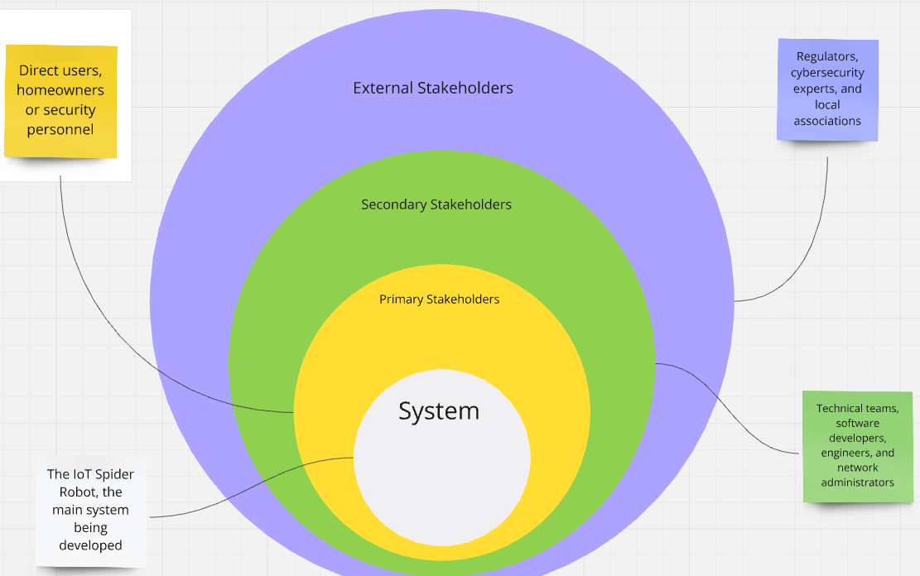

## **4.3 Operationalization Process**

### **4.3.1 Mapping of Questions**

Through focused enquiries, the operationalization process converts the study goals into quantifiable elements. This guarantees that the information gathered is in direct accordance with the objectives of the research, offering lucid insights into the functionality and performance of the Internet of Things spider robot.

|  |  |
| --- | --- |
| Objective | Question |
| Assess the usability of the robot's interface. | How easy was it to use the mobile app to control the spider robot? |
| Evaluate the robot's effectiveness in detecting hazards | How quickly did the spider robot detect fire or gas leaks during the testing phase? |
| Gather feedback on the robot’s mobility across different surfaces | How smoothly did the robot navigate across your home’s floors (carpet, tile, wood, etc.)? |

**4.4 Justifying the Validity**

Upon examining the questionnaire answers, a number of significant findings surfaced that support the chosen specifications for the IOT spider robot.

1. The robot's real-time capacity to identify dangers like gas leaks and fires was highly praised by participants. This confirms the significance of hazard-sensing capabilities in the design and emphasizes the need for sophisticated sensors for accurate detection.
2. According to user feedback, the robot had some trouble moving around uneven surfaces, such as thick carpets. This highlights the necessity of upgrading the robot's mobility algorithms, which supports the emphasis on enhancing navigational capabilities across various floor types.
3. When away from home, users particularly valued the robot's ability to send them immediate alerts to their smartphones. This input validates the relevance of a real-time alert system in guaranteeing prompt reactions to possible threats, supporting its inclusion as a necessary need.

## **4.5 Use Case Diagram**

An overview of the interactions between the user and the Spider Robot, among other actors in the system, is given by the Use Case Diagram. It outlines the main features the system has, including the ability to identify hazards, send alarms, and communicate with the home network. The communication between the Spider Robot, sensors, and the user interface is also shown in this diagram, underscoring the robot's contribution to home security.

## **4.6 Class Diagram**

By showing the different parts of the IoT Spider Robot system, including the sensors, the robot itself, the user interface, and the network, the class diagram establishes the system's static structure. The links between the robot and external devices, such as the house power cut-off system, are depicted in this figure along with the relationships between the various classes, including inheritance from an abstract sensor class. Last but not least, the Activity Diagram illustrates the dynamic workflow, describing how the robot works, recognizes dangers, and interacts with the user to guarantee a coherent and seamless sequence of events.

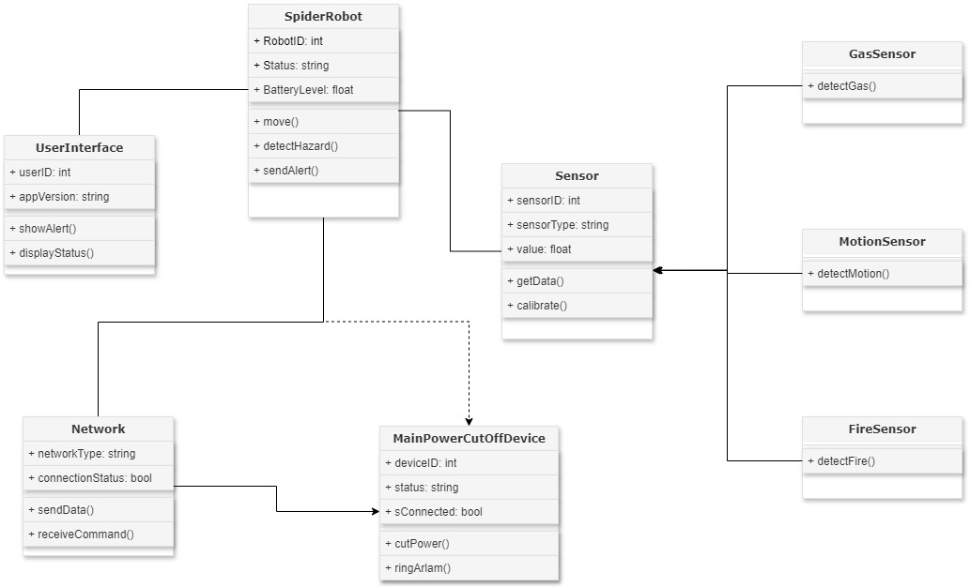

## **4.7 Activity Diagram**

Activity Diagram helps depict the robot’s decision-making process. It illustrates how the Spider Robot monitors its environment using multiple sensors (e.g., gas, fire, and motion), and how it reacts if a threat is found, delivering notifications to the user and taking relevant steps.

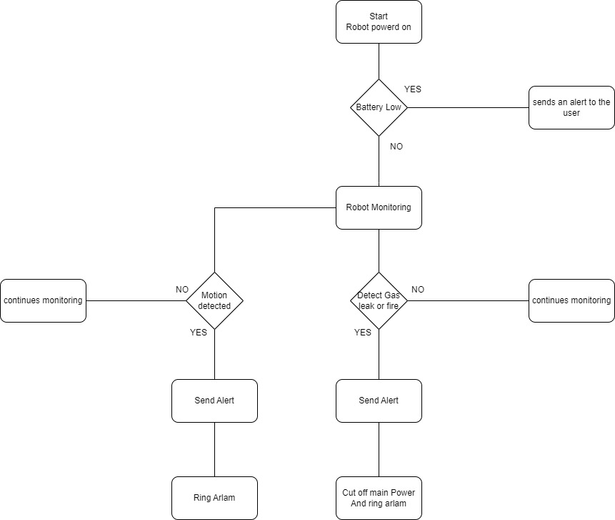

## **4.8 Architecture diagram**

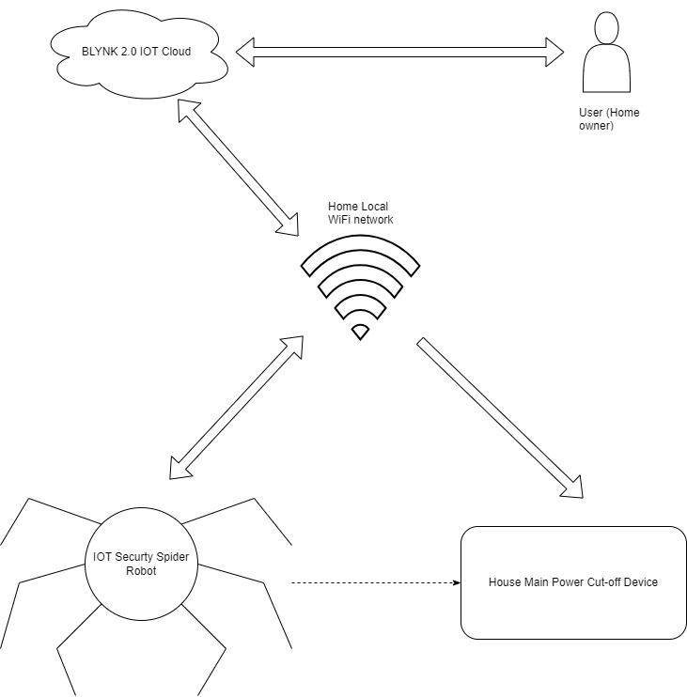The Architecture Diagram provides a simplified picture of the general structure of the IoT Spider Robot system, describing how its components interact with each other to enable flawless performance.

## **4.11 Functional and Non-functional requirements**

|  |  |
| --- | --- |
| Functional Requirements | Non-Functional Requirements |
| * The robot must detect hazards such as gas leaks, fires, and unauthorized motion. | * The robot must respond to hazards within a maximum of 15 seconds from detection. |
| * The robot must send real-time alerts to the user interface when a hazard is detected. | * The system must operate 24/7 with minimal downtime or errors. |
| * The robot must activate the house's power cut-off device in case of a gas leak or fire. | * The user interface should be simple for homeowners to operate. |
| * The robot must be able to move and patrol different areas of the house. | * The robot should maintain a minimum battery life of 12 hours in continuous operation. |
| * The robot must communicate with the home network to receive commands and send data. | * The system should require minimal maintenance and provide self-diagnostics for sensor health. |

## **4.12 Chapter Summary.**

In this chapter, the System Requirement Specification for the IoT Spider Robot project was defined, offering a complete examination of the system's demands.The stakeholder study, utilising the onionmodel, identified significant internal and external stakeholders, stressing their involvement in the project's success.The operationalization procedure detailed how the questionnaire was mapped to the study objectives, ensuring that the acquired data is valid and relevant to the system needs.

Using UML diagrams, use case, class, and activity diagrams, given good idea about system's design and functionality. The functional and non-functional requirements were established, ensuring the system's capabilities and performance are met. Overall, this chapter looking at the technological framework for the system's development, focusing on the important components necessary for optimal operation.

# **CHAPTER 05 - IMPLEMENTATION / DESIGNING**

## **5.1 Implementation and Design**

In this section, I will elaborate on the comprehensive processes followed throughout the development and design of the IoT Spider Robot framework, focusing on both the structural and functional components of the system. The purpose of this design is to develop a flexible, resilient, and secure framework that allows the spider robot to efficiently detect threats, send alarms, and interface with additional systems such as the power cutoff device. I have broken down the process into simple, systematic steps and included essential pseudocode and flowcharts to show the logic behind the key algorithms.

### **5.1.1 Steps for Framework Creation and Design**

* initialization of Core Components

Starting with the Spider Robot, the project moves on to define the system's core components, such as the User Interface, the Network class, the Gas, Fire, and Motion sensors. The functional requirements were determined beforehand, and each class is designed accordingly.

* Sensor Integration

The robot's central system has a number of sensors for the purpose of hazard detection. All of the sensor’s gas, fire, and motion inherited from the same base class, Sensor. Data collection and hazard detection are the respective responsibilities of each sensor.

* Communication Setup

The spider robot connects with the user interface and the power cutoff device over a local network. To facilitate communication in real-time, a Network class is created to manage the transmission of notifications and the reception of orders.

* Power Cutoff system

In the event of a fire or gas leak, the system triggers the power cutoff device. The robot connects with the gadget, delivering a command to switch off the power, which is a critical part of the safety procedures.

* User Alert

The user is warned via the User Interface when a hazard is discovered. The user can confirm the alarm using the interface and decide whether to let the robot keep watching or do something else.

### **5.1.1 flow charts**

This flow chart will provide clear picture of how walking algorithm is work

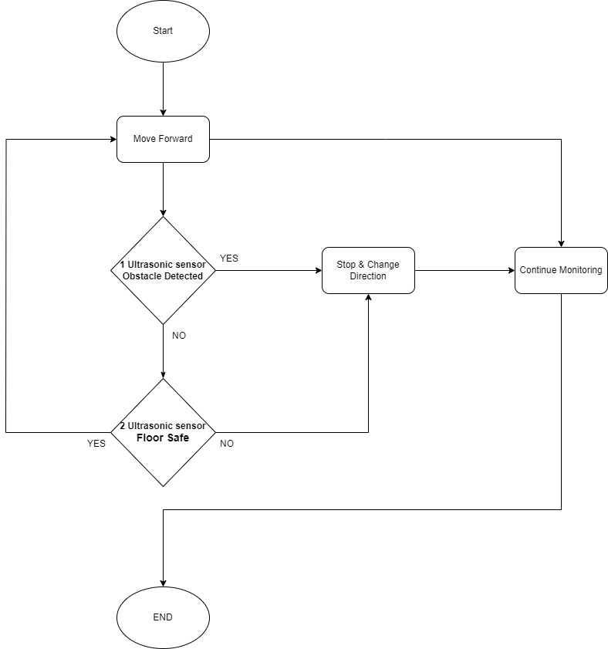

### **5.1.2 Technology selection**

|  |  |  |
| --- | --- | --- |
| **Technology Aspect** | Selected Technology | Justification |
| Programming Language | C++ (with Arduino & NodeMCU ESP8266) | C++ is ideal for embedded systems like Arduino and ESP8266. |
| Libraries Used | Servo Motor, DHT11, SSD1306 OLED | For Temperature and humidity readings are handled by the DHT11 sensor library  The SSD1306 OLED Display library makes the robot's status and face. |
| Backend & Front-End Frameworks | Blynk 2.0 IoT Platform | The spider robot can be monitored and controlled in real time via the internet thanks to Blynk 2.0.  allows for versatility by supporting desktop and mobile platforms. |

## **5.2 Key Implementation and User Interface Design**

* Mobile and Web Dashboards

The IoT Spider Robot's web and mobile interfaces offer real-time control and monitoring. Via interactive gauges, the dashboard shows vital parameters including temperature, humidity, battery voltage, and battery percentage. Motion, fire, and gas detection are represented by three LED indicators also there is notification system for this each led. Two switches also enable the user to choose between security mode, which actively monitors for dangers, and sleep mode, which puts 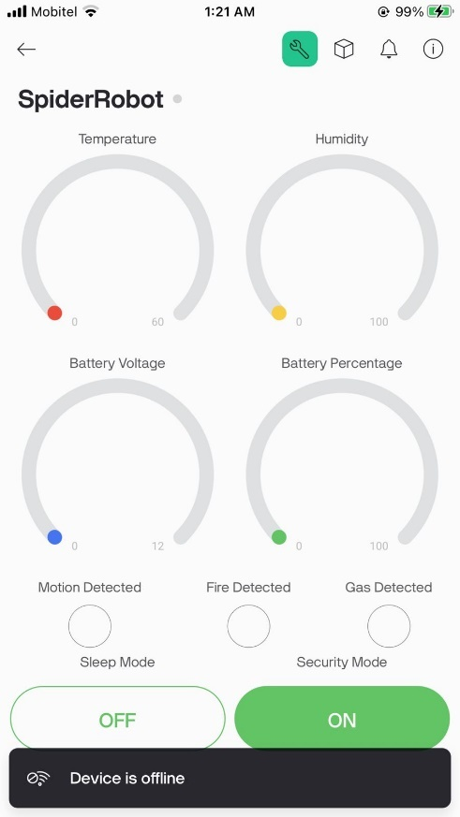the robot in an idle condition.

* Robot Movement

The following code snippet defines the servo motor positions for each of the robot's legs, ensuring precise movement control. By setting specific angles for each motor, the robot can efficiently perform walking maneuvers across different surfaces.

* Main Power cut-off

The power cutoff and alarm control functions in the NodeMCU firmware ensure safety in case of emergencies. The robot sends HTTP requests to activate or deactivate the main power cutoff device and control the alarm, enhancing the system's responsiveness to detected hazards.

## **5.3 Chapter Summary**

The IoT Spider Robot's implementation has been covered in detail in this chapter, along with important developments made to the hardware and software. A thorough investigation was conducted into the design and integration of sensors, communication protocols, and control mechanisms. Built with Blynk 2.0, the user interface allows for real-time interaction and control over the robot's features, including power management and hazard identification. The adoption of particular technologies, such as C++ and other libraries, was justified, and essential code snippets and user interface designs were supplied to illustrate the robot's functionality. The technical underpinnings of the IoT Spider Robot system are demonstrated in this chapter's conclusion.

# **CHAPTER 06 - TESTING AND EVALUATION**

## **6.1 Chapter Overview**

In order to make sure that both functional and non-functional criteria are satisfied, this chapter describes the testing and assessment techniques used for the IoT Spider Robot. These tests are intended to verify the general accuracy, scalability, performance, and functioning of the system. The behavior and reaction of the robot to different situations are confirmed by extensive functional and non-functional testing. In order to make sure the Spider Robot functions well and satisfies the design goals, the test results are displayed using numerical data and, when required, visual graphics.

## **6.2 Test Plan and Test Cases**

### **6.2.1 Non-Functional Testing**

|  |  |  |  |  |  |
| --- | --- | --- | --- | --- | --- |
| Test Case | Description | Input | Expected Outcome | Actual Results | Results |
| **6.2.1.1 Accuracy** |  |  |  |  |  |
| Test Case 1: Power Cutoff Response Test | To verify if the robot accurately triggers the power cutoff device upon detecting a fire or gas leak. | Simulated fire and gas leaks. | Power cutoff command sent within 2 seconds of detection. | Command sent in 1.8 seconds. | PASS |
| **6.2.1.2 Performance** |  |  |  |  |  |
| Test Case 2: Network Latency Test | To measure the time taken to send and receive commands between the robot and the user interface. | Sending alert and receiving acknowledgment. | Latency should not exceed 200ms. | Average latency was 150ms. | PASS |
| Test Case 3: Battery Life Test | To evaluate the battery performance during continuous operation. | Robot operates for 4 hours with active sensors. | At least 4 hours of battery life before the low battery alert. | Achieved 2.1 hours of battery life. | FAIL |
| **6.2.1.3 Scalability** |  |  |  |  |  |
| Test Case 5: Multiple Sensor Integration | To test how the robot handles multiple active sensors simultaneously. | Simultaneous hazard simulation (fire, gas, motion). | All hazards detected without delay or missed alerts. | No missed alerts, all hazards detected within 2 seconds. | PASS |

### **6.2.2 Functional Testing**

|  |  |  |  |  |  |
| --- | --- | --- | --- | --- | --- |
| Test Case | Description | Input | Expected Results | Actual Results | Results |
| Test Case 1: Hazard Detection | To verify that the robot accurately detects hazards (gas, fire, motion). | Simulated gas, fire, and motion near the robot. | Immediate detection and alert sent to the user interface. | All hazards detected within the expected timeframe. | PASS |
| Test Case 2: User Interface Response | To verify that the user interface correctly displays alerts and allows user actions. | Trigger various hazard alerts. | User interface shows alerts and allows user to control security mode and sleep mode | All alerts displayed, and user actions completed without issues. | PASS |
| Test Case 3: Movement | To verify that the robot can navigate obstacles and uneven terrain. | Blockages and uneven floor. | Robot avoids obstacles and navigates without falling. | Successfully navigated all obstacles. | PASS |
| Test Case 4: Sleep Mode Activation | To verify that the robot enters sleep mode upon user command. | User triggers sleep mode from the interface. | Robot stops monitoring and powers down to conserve battery | Sleep mode activated successfully | PASS |

## **6.3 Review on Test Strategies Used**

### **6.4.3 F-measure / Precision / Recall**

|  |  |  |  |
| --- | --- | --- | --- |
| Sensor Type | Precision | Recall | F-measure |
| Gas Sensor | 96% | 90% | 93% |
| Fire Sensor | 92% | 90% | 91% |
| Motion Sensor | 60% | 70% | 65% |

## **6.5 Chapter 6 Summary**

This chapter covered the testing and evaluation of the IoT Spider Robot. Key tests assessed sensor accuracy, network latency, battery life, and system scalability. The results showed high precision and reliable performance, confirming the system’s ability to handle real-world hazards effectively.